**Day 3**

**C++ Recursion, Arrays, Strings, Structures**

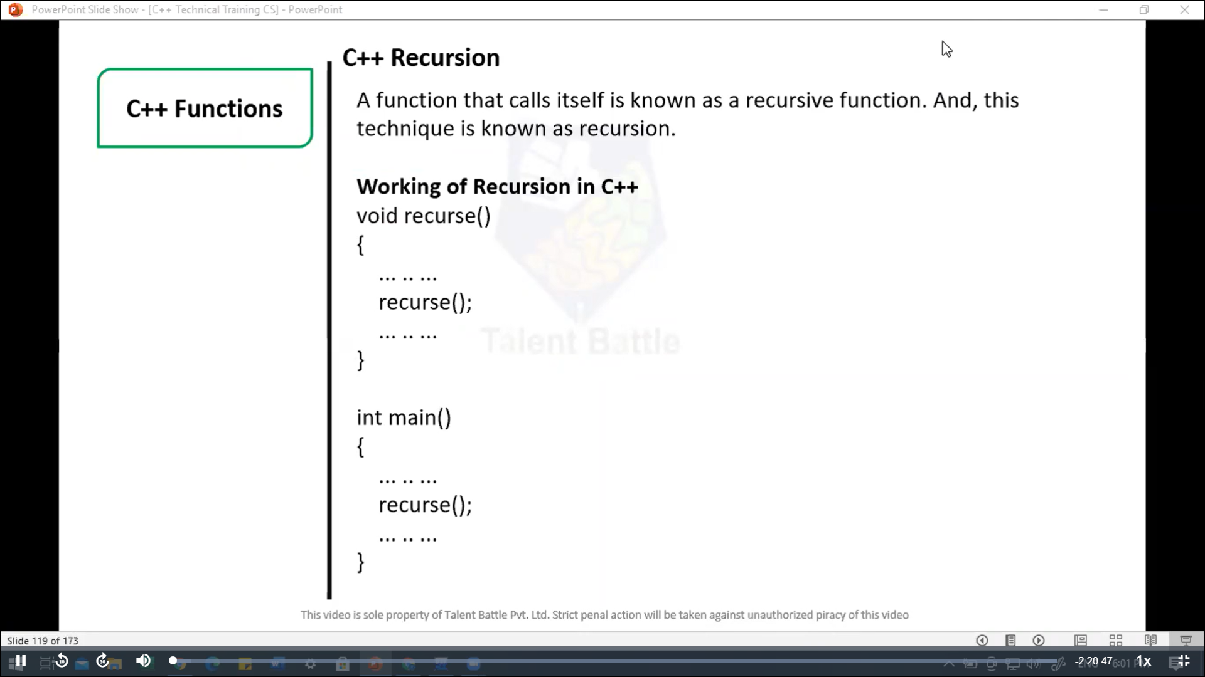

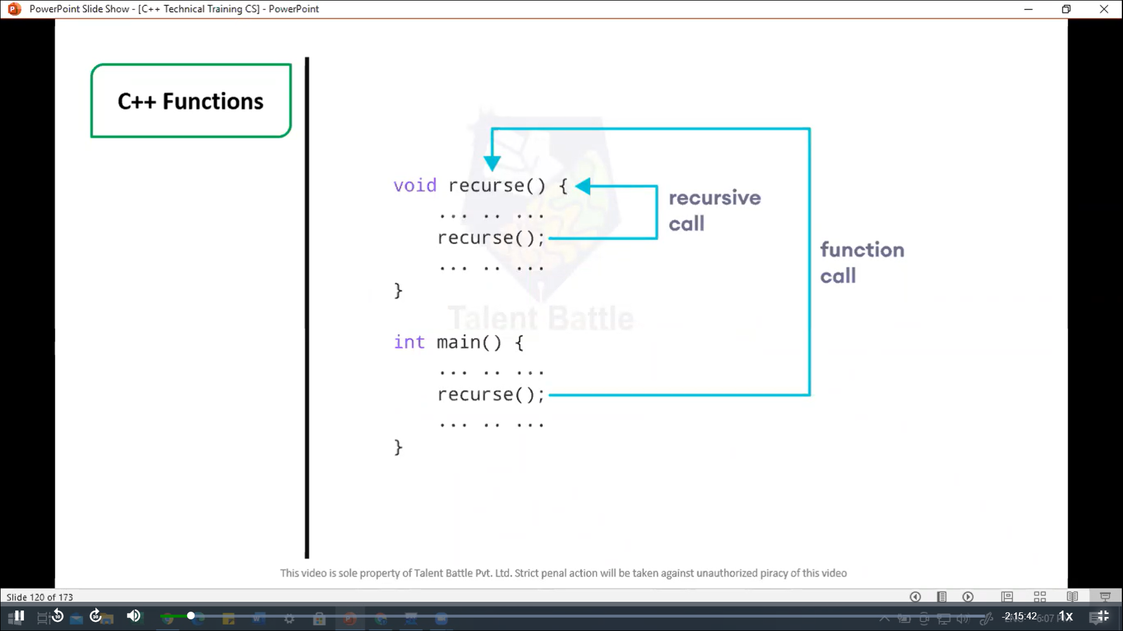

// C++ Recursion, Arrays, Strings, Structures

// Factorial of n = 1*2*3*...*n

#include <iostream>

using namespace ***std***;

int *factorial*(int); // functoin prototype

int *main*(){

  int n***,*** result;

  cout ***<<*** "Enter a non-negative number: ";

  cin ***>>*** n;

  result = *factorial*(n);

  cout ***<<*** "Factorial of " ***<<*** n ***<<*** " = " ***<<*** result;

  return 0;

}

int *factorial*(int ***n***) {

  if(n > 1){

    cout ***<<*** n ***<<*** " " ***<<*** n\**factorial*(n-1) ***<<*** endl;

    return n * *factorial*(n-1);

  } else {

    return 1;

  }

}

**==========================================**

**Output:**

**Enter a non-negative number: 5**

**Factorial of 5 = 120**

**--------------------------------**

**Process exited after 2.145 seconds with return value 0**

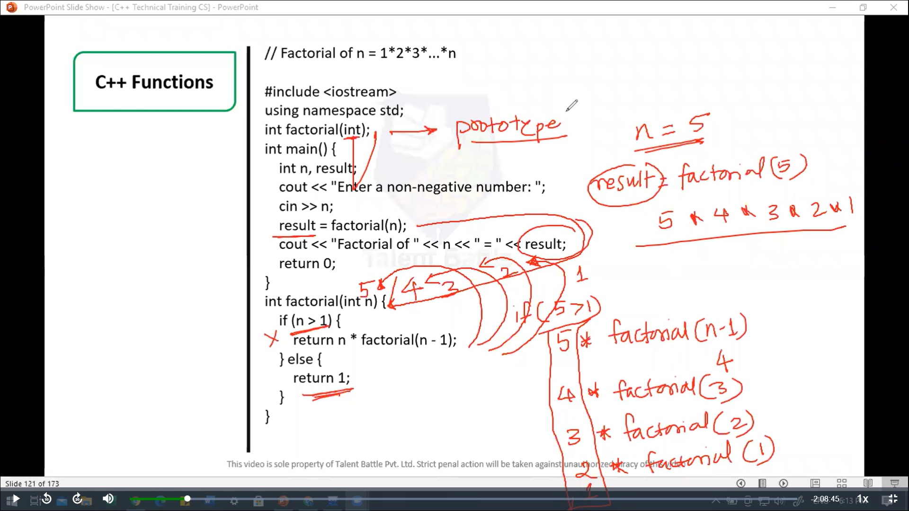

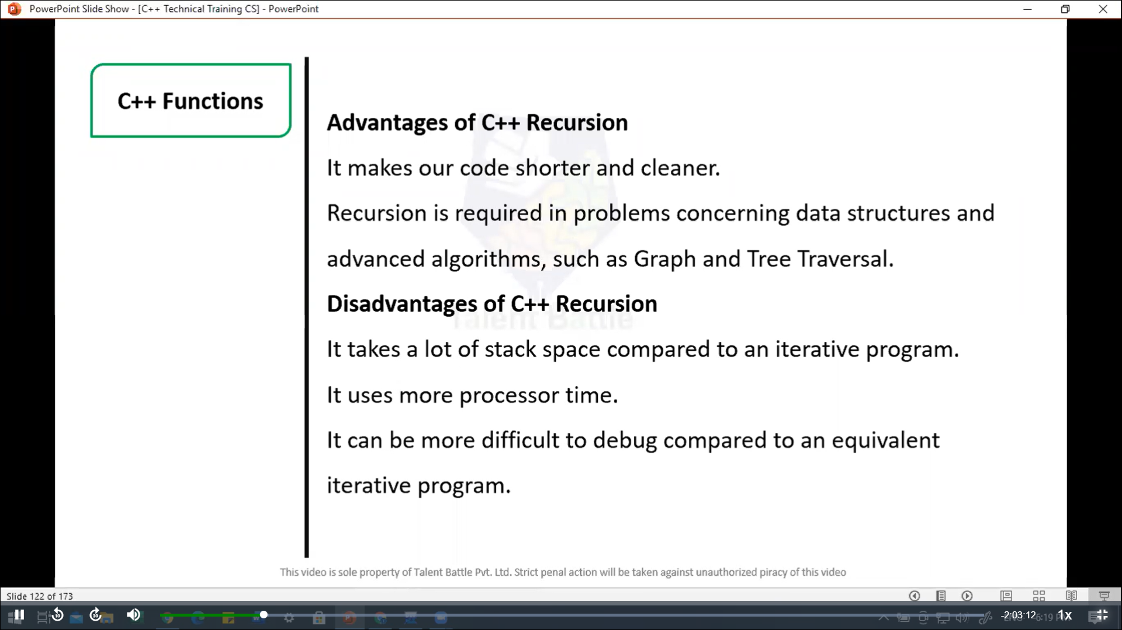

//======================================================

// C++ Return by Reference

/*

In C++ Programming, not only can you pass values by reference

to a function but you can also return a value by reference.

*/

#include <iostream>

using namespace ***std***;

// Global variable

int num;

// function declaration

int& *test*();

int *main*(){

*test*() = 5;

  cout *<<* num;

  return 0;

}

int& *test*(){

  return num;

}

**=============================================================**

**5**

**--------------------------------**

**Process exited after 0.1432 seconds with return value 0**

